Project Management

Assignment 1

Brandon Hewlett

1.

Project Charter

Date

|  |  |  |  |
| --- | --- | --- | --- |
| **Project Title**: Hackfest Side-Scroller Space Shooter: Refinement | | | |
| **Project Start Date:** October 4, 2013 **Projected Finish Date:** October 4, 2014 | | | |
| **Budget Information:**  $150,000 | | | |
| **Project Manager:** Brandon Hewlett – 705-770-3326 | | | |
| **Project Objectives:**  Refine what we already have with the current game. We have a very good starting point, and one year will allow us to refine the game to a point where it is ready for a retail release on Steam. Once our game is ready, we will need someone to run a social media campaign to drum up support for our game on Steam Greenlight. | | | |
| **Success Criteria:**  We have succeeded if we create a game that is ready for a retail release, and we can get it on online distribution sites such as Steam. Also, we need to come up with a better name than “Hackfest Side-Scroller Space Shooter”.  Ready for Retail Release is defined as:   1. Small Story Mode – 2-4 hours minimum 2. High Scores Leaderboard 3. Increase level count by 200% 4. MUST BE BUG-FREE (or as close to bug-free as possible.) NO GAME-BREAKING BUGS | | | |
| **Approach:**  We will go with an agile approach for this project. This will allow us to gradually go through the game’s mechanics and improve them individually. This will also allow us to come together frequently and discuss our progress. Finally, this will allow us to adapt to new problems that crop up unexpectedly.  Our progress will be reported to our sponsor on a weekly basis. During the development cycle, the sponsor will have a fair amount of input into what happens. However, we will not allow the scope of the project to fly out of control. This would strain our budget to the breaking point. | | | |
| **Roles and Responsibilities** | | | |
| ***Name and Signature*** | ***Role*** | ***Position*** | ***Contact Information*** |
| **Brandon Hewlett** | **Lead Programmer** | **Project Lead** | **fakeemail@fakesite.com** |
| **Hugh Jass** | **Programmer** | **Second-in-Command** | **fakeemail@fakesite.com** |
| **Johnny Gat** | **Art** | **Art Lead** | **fakeemail@fakesite.com** |
| **Mike Turner** | **Sound** | **Sound Lead** | **fakeemail@fakesite.com** |
| **Sarah Jesper** | **Design** | **Design Lead** | **fakeemail@fakesite.com** |
| **Larry Pitt** | **Programmer** | **Programmer** | **fakeemail@fakesite.com** |
| **Stephanie Lorry** | **Design/Social Media** | **Social Media Lead** | **fakeemail@fakesite.com** |
| **Karen Fammy** | **Design** | **Designer** | **fakeemail@fakesite.com** |
| **Jacob Tanman** | **Programmer/Playtest** | **Playtest Lead** | **fakeemail@fakesite.com** |
|  | | | |
| **Comments:** It could be possible, later on in development (3-6 months in) to attempt a KickStarter Campaign. This would allow us to increase our budget through crowdsourcing. If we are able to drum up support through word of mouth and Social Media, it is possible (though highly unlikely) to triple our funding.  Get in contact with famous YouTube personalities who are popular in the indie game scene (TotalBiscuit, JesseCox, and IndieStatik come to mind) in order to amplify the word-of-mouth aspect. | | | |

2.

We have decided to go with an agile approach for this project. It makes sense in this case because our game is, technically, already made. The only thing we need to do is refine what we have, and add new content. The frequent meeting that come with the agile approach will allow us to periodically discuss our progress. Our devs will report to the Project Lead daily, during a small, 15-minute meeting. They will report on what they’ve got done, where they’re stuck, and any ideas they have that could improve the project. This information will be compiled and sent to our sponsor by the project lead at the end of each week.

3.

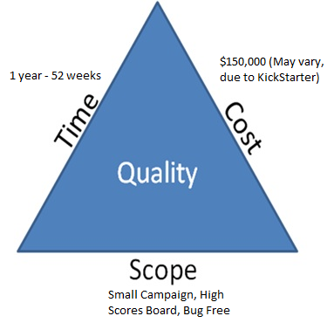

We are not left with a large amount of room for adjustment for the Triple Constraint. The timeframe and the budget have already been set for us. This means that the scope is, more or less, fixed.

The Scope of this project is not entirely huge. Expand the campaign to 2-4 hours, Create a high score board, and make sure it is bug free at launch.

However, we could see an increase in our budget if we ran a Kickstarter campaign. Kickstarter is a site that allows people with projects to appeal to the general public for funding. This is a gamble on both ours and the consumer’s part, and a cost-benefit analysis would need to be run in order to determine if we would benefit from this.